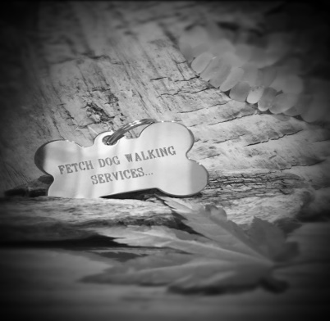
Fetch Dog Walking Services
71 Stoneygate Road,
Leicester, LE2 2BP
07900 343 882
Email: fetchdws@hotmail.com

FREE Initial Consultation:
Call to arrange a free consultation. I will come out to meet you and your dog or dogs, become familiar with your house, pick up keys and complete all necessary paperwork. This will also give you the opportunity to meet me face to face and answer any further questions you may have?

Group Dog Walk 1hour visit:
This includes a 45 minute walk, play, drying paws and change water £14 per walk
Each additional pet for same home £11 per walk

Ad hoc walks (less than 2 regularly weekly walks)
This includes a 45 minute walk, play, drying paws and change water £15 per walk
Each additional pet for same home £12 per walk

**For Weekend walks please add £4 per walk per dog**

50 pence per every extra mile outside of a 3 mile radius for collection and drop off.

Payments can either be made on line through your bank or in cash. All outstanding balances must be settled within 7 days or a late charge of £10 will be applied. We understand that plans can change. Fetch don’t charge for cancellations with adequate notice. Cancellations made after 6pm the night before the visit will be chargeable £10.00.
Bank Details
Fetch Dog Walking Services

BANK DETAILS CAN BE GIVEN AT INITIAL MEETING
Reference: *************
Please ALWAYS enter your name and invoice number

