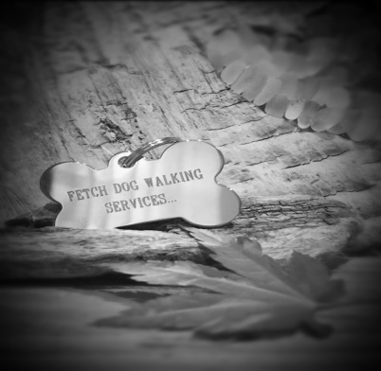
Fetch Dog Walking Services
71 Stoneygate Road,
Leicester, LE2 2BP
07900 343 882
Email: fetchdws@hotmail.com

Terms and Conditions

1. The Client is solely responsible for any and all harm or damage caused by their dog while it is under the care of Fetch Dog Walking Services, or is using any other services provided by Fetch DWS, and agrees to indemnify Fetch in full against any liability arising from such harm or damage to third parties.

2. The Client agrees that, in admitting their dog, Fetch has relied on the Client’s representation that their dog is in good health and has not harmed or shown aggression or threatening behaviour toward any person or any other dog.

3. All dogs will be subject to an initial assessment by Fetch staff prior to using Fetch. Fetch reserves the right to refuse any dog deemed in their opinion to be, or have the potential to be, dangerous or disruptive.

4. The Client agrees to notify Fetch immediately of any unwelcome, aggressive, procreative, or dangerous behaviour of their dog that has potential to cause harm to any other dog or individual.

5. Fetch offer services where dogs interact in groups and the Client accepts that during the course of normal dog play their dog may sustain injuries. All dog play is carefully monitored to avoid injury, but scratches, punctures, torn ligaments, or other injuries may occur despite the best supervision.

6. The Client is responsible for the full cost of treatment of any injuries or illness that their dog receives while under the care of Fetch together with any associated costs. The Client authorises Fetch to seek veterinary advice and/or treatment as they deem necessary. Where possible this will be carried out by the Client’s preferred Vet, but this cannot be guaranteed in an emergency. The Client accepts that Fetch may at their discretion use any registered Vet and the Client agrees to pay all such costs.

7. Fetch DWS reserves the right to refuse the Client fails to provide adequate proof of vaccinations, micro chipping and insurance.

8. Bitches may attend Fetch while in season or pregnant. However they will be walked on a one to one basis and charge accordingly.

9. The Client accepts that even though their dog is vaccinated against Bordetella (Kennel Cough) there is a chance that their dog can still contract Kennel Cough. The Client agrees that they will not hold Fetch responsible if their dog contracts Kennel Cough while attending.

10. The Client agrees to take any necessary measures or precautions to ensure that their dog is continuously free of contagious, infectious, or otherwise communicable diseases. The Client further agrees to notify Fetch immediately of any infectious and/or contagious disease or conditions their dog has been exposed to or is affected by. Fetch reserves the right to refuse admission until satisfied that the condition is resolved.

11. The Client agrees that Fetch is not responsible for any lost, stolen, or damaged collars, tags, clothing or any other item left with their dog.

12. The Client agrees to ensure their dog has not eaten in the hour before pick up by Fetch to ensure sufficient time to digest food before any exercise or play. Failure to do so may result in the potentially life-threatening condition Bloat (Gastric Torsion).

13. The Client agrees to provide keys/arrange access to the dog for the agreed appointment. Failure to do so will result in a cancellation for that day’s service and will be paid in full by the client.

14. The Client agrees that, by signing the key holder waiver form this will indemnify Fetch in full against any liability arising from loss or damage to the property or its contents, in present and future circumstances.

Please sign and date to say you have read the above terms and conditions and agree to them.
Name:
Sign:
Date:

