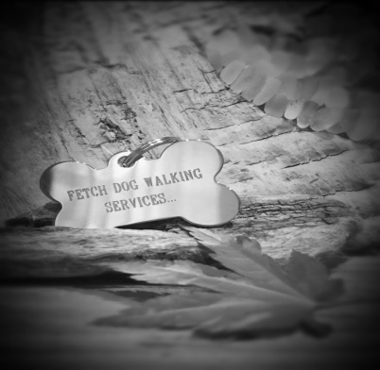
Fetch Dog Walking Services
71 Stoneygate Road,
Leicester, LE2 2BP
07900 343 882
Email: fetchdws@hotmail.com

Contract of Service
Please read this form and the accompanying Terms and Conditions carefully to ensure Fetch DWS can provide the highest level of care and safety for your dog/dogs. Please then complete and sign the Terms and Conditions, Off the Lead Consent and Waiver of Liability forms below.

General Information
Name:
Address:
Postcode:
Email Address:
Phone:

Emergency Contact
Name:
Phone:
Vets Name:
Address:
Postcode:
Phone:

Security Information
Gate Codes:
Alarm Instructions:

Dog's Details
Name
Age
Gender (M/F)
Is your dog/s Microchipped?
Is your dog/s Insured?
Neutered?
Date of your bitches last season if not spayed?
Are you up to date with your dog/s vaccinations?
Is your dog/s allowed treats when they are with us?
Please list any pre-existing or current health conditions and list any medication your dog is currently taking and instructions.

Please describe any restrictions on your dog’s activity (e.g. due to physical limitations such as hip dysplasia)

Social Skills
How does your dog react to other people and dogs when on walks?

Please provide details if your dog is anxious around, or frightened by anything?

Does your dog have good recall skills? Will your dog chase livestock, squirrels, cats etc?

Routine
Please describe pick up and return routine? Which room to be left in to be fed or not etc?

Disclaimer & Waiver of Liability:
The information I have given in this application is true, correct and complete to the best of my knowledge. I have read and agree to abide by the Terms and Conditions for services received from Fetch DWS. I hereby indemnify Fetch DWS and their staff against liability of any kind whatsoever arising from my dog’s participation in any services offered by Fetch DWS.
Full Name:
Sign:
Date:

Off the Lead Consent Form:
I agree to Fetch DWS having the right to allow my dog off the lead and understand that all terms and conditions remain the same. I have read and agree to abide by the Terms and Conditions for services received from Fetch DWS. I hereby indemnify Fetch DWS against liability of any kind whatsoever arising from my dog’s participation in any services offered by Fetch DWS.
Full Name:
Sign:
Date:

Key Holder Disclaimer & Waiver of Liability:
I have read and agree to abide by the Terms and Conditions for services received from Fetch DWS. I understand that this form acts as permission to hold keys to my property, which I have provided willingly. I hereby indemnify Fetch DWS against liability of any kind whatsoever arising from damage or loss of any property.
Full Name:
Sign:
Date:

